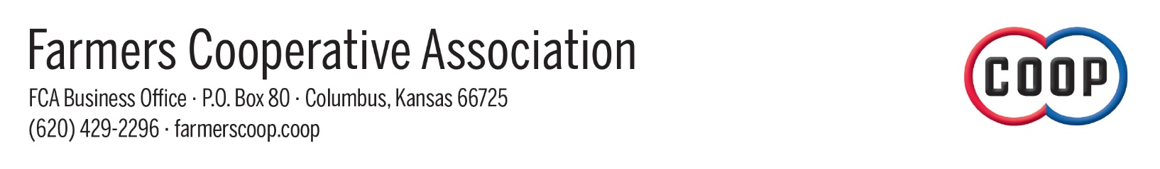

FOR IMMEDIATE RELEASE

Farmers Cooperative Association Awarded by Kansas Department of Commerce

Columbus, KS (October 12, 2023) – Businesses and individuals from across the state were honored Thursday night in Wichita for their outstanding contributions to Kansas communities and the state’s economy at the Kansas Department of Commerce’s 2023 To the Stars: Kansas Business Awards ceremony.
The Farmers Cooperative Association was recognized as a Regional Award Winner in the Agribusiness category. Governor Laura Kelly included a professional acknowledgment with the award.
"Your association was nominated because you are creating job opportunities, products and services, innovating and diversifying the local marketplace, building community identity, and so much more. You have made an impact in your community and that impact has been noticed," wrote Governor Kelly.
"Your business has demonstrated the tenacity, determination, and creativity needed to persevere regardless of circumstance. These values are at the heart of what it means to be a Kansan."
FCA General Manager Matt Case and members of the FCA leadership team were in attendance for the ceremony.
“We are honored to be recognized by the Kansas Department of Commerce,” said Case. “The continued success of the FCA is the result of our unwavering dedication to our member-owners and community by our employee team and board of directors. We remain steadfast in our mission to support our local agricultural community.”
Founded in 1950, the FCA is proud to be a member-owned cooperative with locations in Baxter Springs, Chetopa, Columbus, and Galena, Kansas. The primary mission of the FCA is to provide unwavering support to the local agricultural community by consistently offering quality products, progressive services, competitive prices, and a dedicated professional employee team.
The FCA provides comprehensive agricultural services to its members and the local farming and ranching community. The FCA strives to be a competitive and forward-thinking cooperative. They maintain a dedicated staff committed to helping their patrons, their operations, and the agricultural community.
For additional information, please visit the FCA website at farmerscoop.coop or email info@farmerscoop.coop. Follow the FCA on Facebook and Instagram for current events and announcements.
###

*High-resolution photo is included for use at your discretion.
Caption: FCA General Manager Matt Case pictured with members of the FCA leadership team accepting the Regional Award in the Agribusiness category from the Kansas Department of Commerce. Photo credit to the Farmers Cooperative Association.

* Please contact FCA Communications Manager Autumn Fuhrman at (918) 533-5397 or afuhrman@farmerscoop.coop with questions.

